GREATER NOTTINGHAM STRATEGIC PLAN GROWTH OPTIONS CONSULTATION JULY 2020 – RUDDINGTON SUMMARY

EXISTING AND COMMITTED HOUSING IN RUDDINGTON
It is considered that Ruddington has scope to sustain around 525 dwellings in total adjacent to the village, based on the capacity of local services and the availability of suitable sites for development. (Rushcliffe Borough Council’s adopted Local Plan Part 2)
Committed development to the end of 2028 has already been increased from 525 to 588 houses.
The 2011 Census recorded a total of 3,146 houses in Ruddington. 2028 Ruddington will have at least 3,734 houses by 2028.

HOUSING ASSOCIATED WITH PROPOSED SITES
Based upon figures in the report the number of houses for each site would be as follows:
Site Reference 12.1 (West of Pasture Lane) 595 - 700 houses
Site Reference 12.2 (North Road) 172 - 203 houses
Site Reference 12.3 (East of Loughborough Road) 996 - 1,172 houses
Site Reference 12.4 (Land south of Wheatcroft Island, Flawforth Lane) 1,904 - 2,240 houses
Should all of the sites be developed this would result in an increase in housing of 107%

SUSTAINABLE TRAVEL
The Department for Transport advise that key facilities and amenities should be located within 1600m.
None of the proposed new sites can be described as ‘a walkable neighbourhood’ as described by ‘The Manual for Streets’ as the vast majority of facilities are in excess of 1600 metres from the centre of each proposed site. Existing car parking facilities within the centre of Ruddington are already limited. With the addition of an extra 588 houses it is extremely likely that these facilities will be overwhelmed by 2028.

FLOOD RISK
Extracts from the Environment Agency flood risk maps for Sites R12.1 (The West of Pasture Lane) and R12.2 (North Road) are shown below:
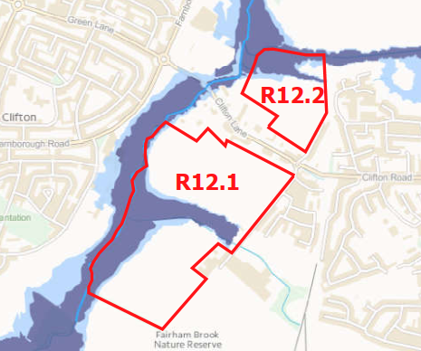
The dark blue areas represent Flood Zone 3 where residential development should not be permitted.
The AECOM report states that ‘The West of Pasture Lane (Site R12.1) and North Road (Site R12.2) sites include flood zones and landscape constraints. These sites are potentially unsuitable for development’.

EDUCATION INFRASTRUCTURE
Ruddington does NOT have a Primary School. It has an Infant’s School, uniquely sited within a Private residential area and a Junior School sited at the opposite side of the village to the Infants School.
The proposed additional 588 houses that are due to be built by 2028 are likely to place demands on the existing schools that would exceed their capacity.

IS THERE A NEED FOR MORE HOUSING?
The ‘Nottingham Housing Market Area Local Housing Need’ in Appendix 1 of the Greater Nottingham Strategy Plan appears to indicate that there is sufficient housing supply already identified until 2038.
Figure A1.1 in Appendix 1 of The Strategic Plan Area calculates a need for 51,580 houses, for the period from 2018 to 2038. Figure A1.1 in Appendix 1 indicates that there is a current estimated supply of 53,264 houses. It is therefore unclear why a strategy is required for even more housing.

If growth is still required up to 2038 it should be concentrated in a new Garden town near the A453 and M1. Extensions to existing settlements are less sustainable and much more damaging to existing rural assets. There is plenty of time to plan this properly.

FUTURE OF THE GREEN BELT
Retain all the Green Belt protections south and east of Nottingham. The principles of urban coalescence apply equally to large existing settlements such as Radcliffe and Ruddington as they do to the towns to the north of the City. This has been accepted in previous Planning policies. There is no evidence to support this change.

